Peer to Peer Messaging app

Flow Chart

Connor Cuffe

Beaumaris secondary college

Table of Contents

Flow charts 3

Legend 3

Main Process Loop 3

End to End Encryption 4

Group and direct messages 6

Peer to Peer network 9

Secure Logon 10

# Flow charts

## Legend

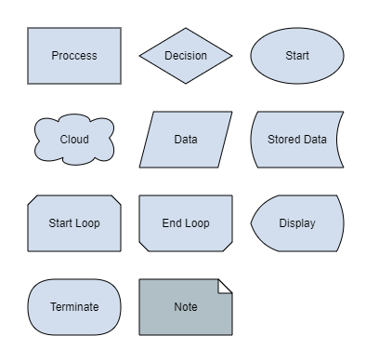

Figure : Legend

## Main Process Loop

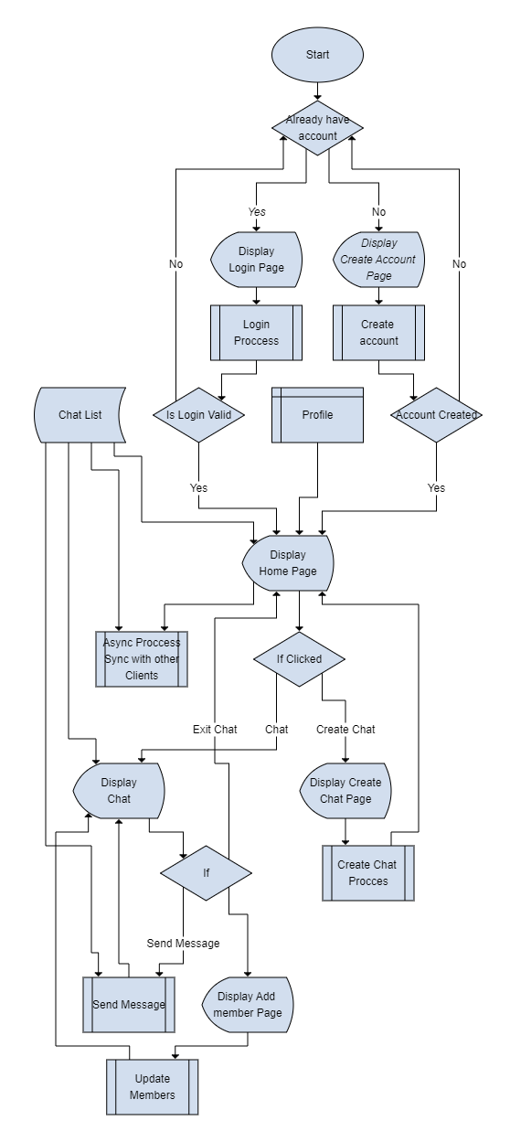

Figure : Main Process loop

## End to End Encryption

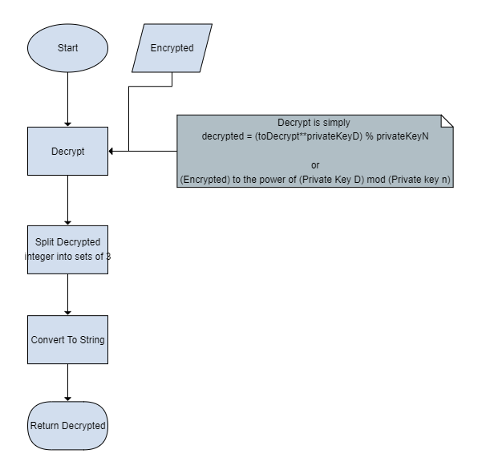

Figure : Decrypt Process

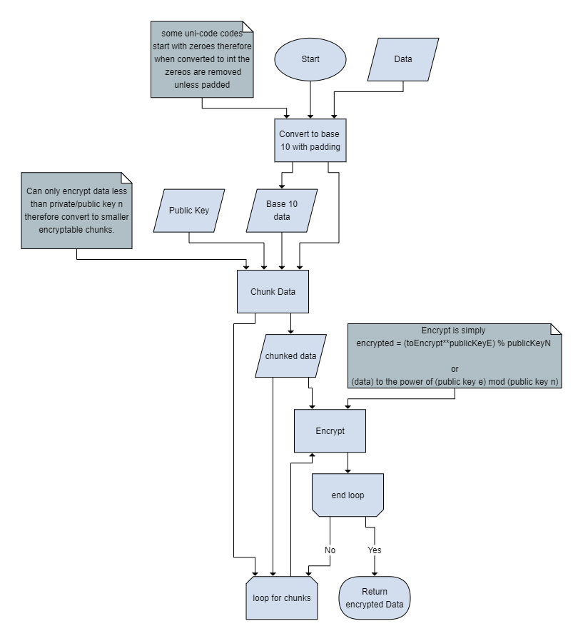

Figure : Encrypt Process

## Group and direct messages

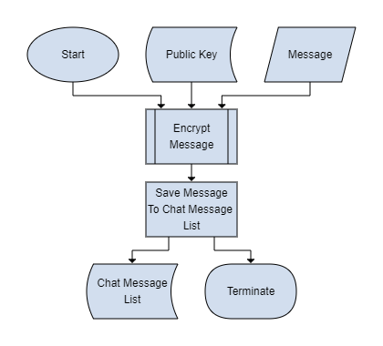

Figure : Create Chat

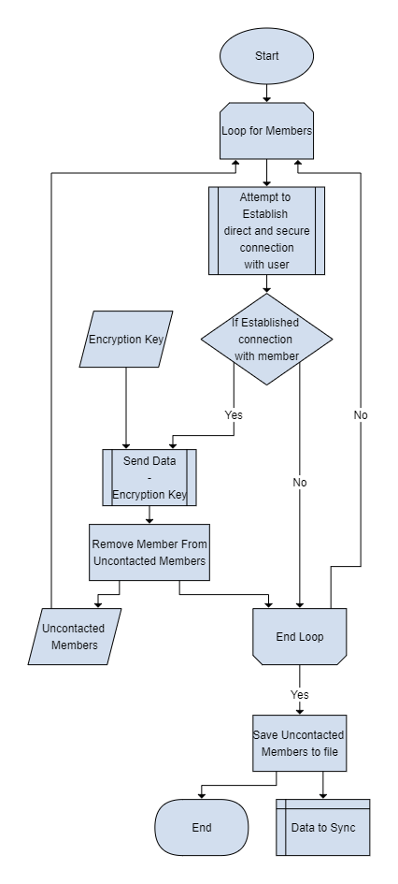

Figure : Update Members Process

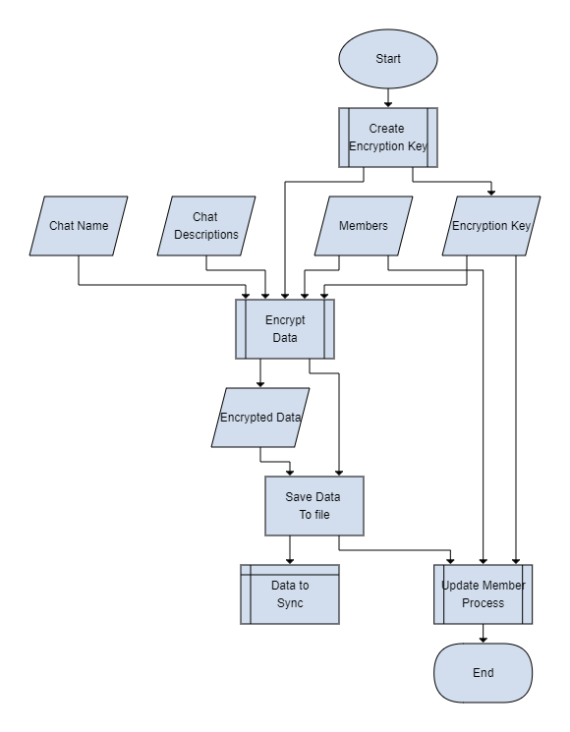

Figure : Send Data Process

## Peer to Peer network

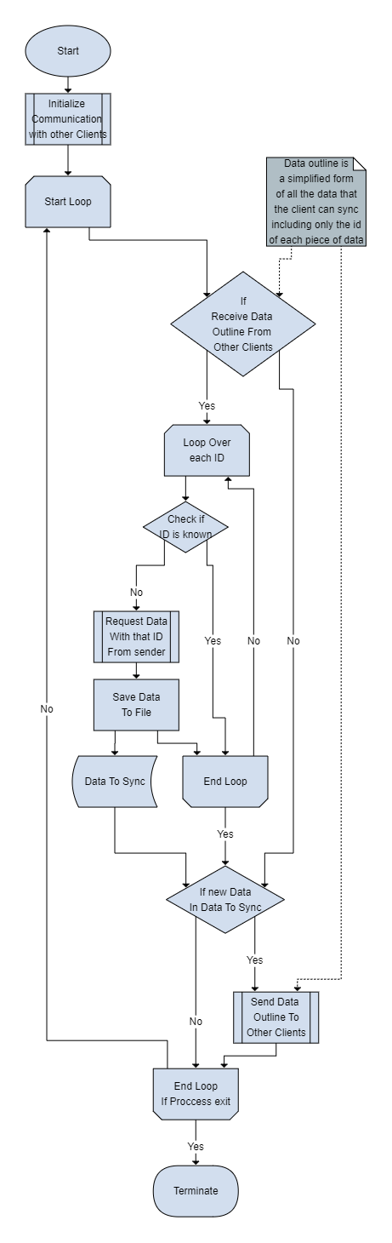

Figure : Sync with other Clients

## Secure Logon

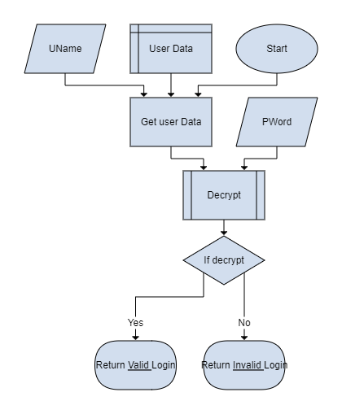

Figure : User Validation Process

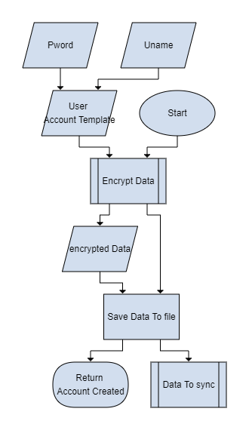

Figure : Create Account Process